Relax and Unwind

Need to get away from it all for a day or two? Come and experience some good old retail therapy followed by a bit of pampering; it could be just what the doctor ordered! You'll be spoilt for choice here in Ashford and Tenterden so here's some ideas for a relaxing short break, or even just a day.

Two Day Itinerary

Day One - Shop 'til you drop!

Morning
Start the day with a visit to the charming country town of Tenterden. The tree-lined high street offers a relaxing experience for you to discover boutiques, antique shops chock full of items from bygone times and some fantastic independent stores offering something that little bit different. In fact it's just the place to find that special gift that you've been searching for.
Take a wander through the side streets and experience the architectural delights that await. You'll find cobbled alleys and timber framed buildings as well as the beautiful medieval church of St. Mildred's and a splendid Georgian Town Hall.
Stop off for coffee in one of the many tea rooms or if it's lunch you're after there is a great selection of traditional inns and restaurants to choose from, all conveniently clustered around the High Street.
From the High Street, wander down Station Road and discover the Kent & East Sussex Railway, a full-size working steam railway. Watch the trains as they pull in and out of the station, or if time allows, hop on board and take a trip to Bodiam Castle through unspoilt countryside.
And if you're looking for somewhere to stay the night you can take your pick from cosy B&Bs, traditional inns and lovely hotels.

Tenterden High Street 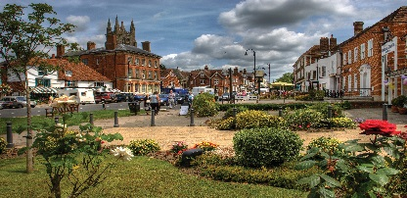

Eating and drinking

Afternoon
Take the 20 minute drive east towards Ashford and head for the Ashford Designer Outlet. With around 80 stores selling favourite brands at up to 60% less you will probably want to make an afternoon of it. Iconic brands, high street favourites and athletics labels are just some of the finds here, along with cafes, restaurants and a children's play area. And there's no need to hurry as stores stay open late.
And if you're hungry for more, Ashford town centre is just a five minute ride away. Discover County Square with over fifty stores including Debenhams and M&S whilst Park Mall shopping centre is home to some quirky independent local stores. There's also a street market in the lower high street on Tuesdays, Fridays and Saturdays.

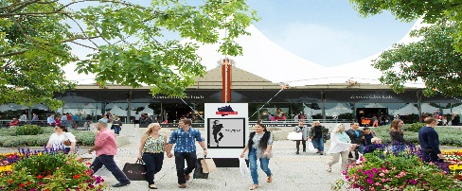
Ashford Designer Outlet
T: 01233 895900

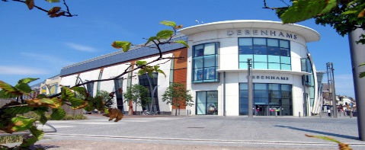
County Square Shopping Centre
enquiries@countysquareashford.co.uk
T: 01233 634001

Day Two - Time to relax
If it's a little bit of rest and relaxation you're after then you've certainly come to the right place. Indulge in an overnight stay for the full pampering experience, or if you just have a few hours then there's still plenty of time to enjoy a range of treatments using luxury products.
Experience the grandeur of Eastwell Manor, a Champneys Spa hotel situated within beautiful landscaped gardens and just five miles from Ashford International Station. Stay in the Manor or in one of the delightful mews cottages in the grounds. The High Speed train can bring you from London to Ashford in just 38 mintues.
Discover the tranquility and luxury of Green Farm Spa and Well-being centre set deep in the heart of the countryside. Green Farm is so much more than a spa; why not bring a group of friends along and stay in the fabulous barn on site. Or sign up for either a yoga or well-being weekend.
Superb facilities await you at the Ashford International Hotel, a four star modern hotel with an excellent spa and indoor pool. Or London Beach Hotel, Spa and Country Club situated on the outskirts of Tenterden offers both saline and hydrotherapy pools along with steam and sauna rooms and a tempting array of treatments.
And if you can't tear yourself away, discover some amazing places to stay in Ashford and Tenterden. Download our visitor guide or visit the website.

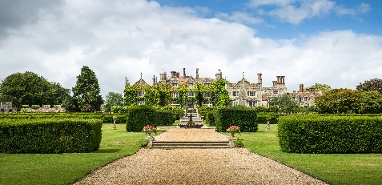
Eastwell Manor, a Champneys Spa hotel
enquiries@eastwellmanor.co.uk
T: 0843 561 2010
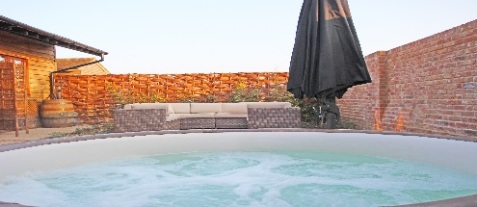
Green Farm Spa
info@greenfarmkent.co.uk
T: 01233 634001
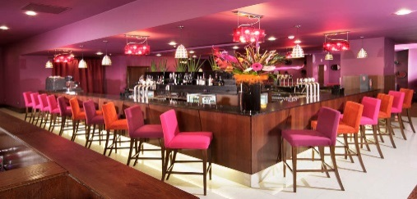
Ashford International Hotel
ashfordreception@qhotels.co.uk
T: 01233 219988

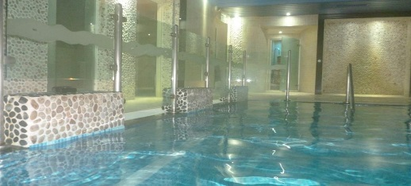
London Beach Hotel, Spa & Country Club
enquiries@londonbeach.com
T: 01580 766729

